Project Design Phase-II
Data Flow Diagram & User Stories

Date | 31 January 2025
Team ID | LTVIP2026TMIDS76104
Project Name | Flavour Fusion AI-Driven Recipe Blogging
Maximum Marks | 4 Marks

Data Flow Diagrams:
A Data Flow Diagram (DFD) is a traditional visual representation of the information flows within a system. A neat and clear DFD can depict the right amount of the system requirement graphically. It shows how data enters and leaves the system, what changes the information, and where data is stored.

Key Data Transitions:
- User Input: The "Citizen Blogger" provides a recipe topic (e.g., "Japanese Fusion Tacos") and a word count target.
- Prompt Engineering (Process 1.1): The system enriches the user's input with structural instructions (e.g., "Include prep time, ingredients, and a 3-paragraph intro") to ensure the AI output meets blogging standards.
- Authentication & API Call (Process 1.2): The system securely retrieves the GEMINI_API_KEY and transmits the payload to Google’s Gemini-2.5-Flash model.
- Generative Processing: The AI generates a Markdown-formatted response, ensuring a logical flow from ingredients to instructions.
- Interactive Rendering (Process 1.3): While data is in transit, the UI triggers a "Jokes & Facts" stream to keep the user engaged.
- Final Output: The processed Markdown is rendered as a clean, structured blog post on the Streamlit interface.
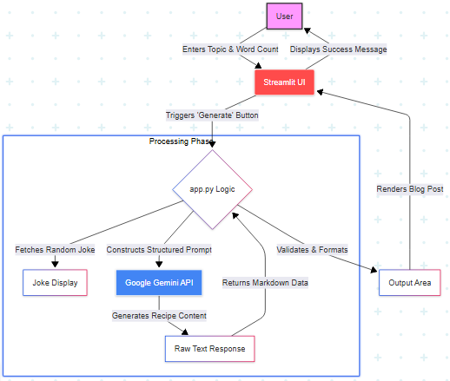

User Stories

For Content Creators & Bloggers
- As a food blogger, I want to specify a target word count so that the generated content fits my website's SEO requirements and layout.
- As a busy creator, I want to see entertaining content like programmer jokes while the AI is generating my recipe so that the wait time feels shorter and more engaging.
- As a culinary writer, I want the AI to include cooking tips and recipe variations so that my blog post provides more value to my readers than a simple instruction list.
- As a non-technical user, I want to input a simple recipe topic and receive a fully formatted Markdown response so that I don't have to spend time on manual styling and headers.

For Home Cooks & Enthusiasts
- As a home cook, I want the AI to generate clear, step-by-step instructions so that I can follow the recipe easily without confusion.
- As a dietary-restricted cook, I want to input specific constraints (like "Vegan" or "Gluten-Free") in the topic field so that the AI generates recipes safe for my needs.

